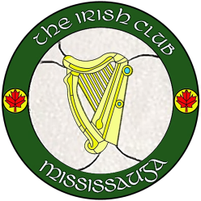
2019 MEMBERSHIP APPLICATION FORM
Membership Number

PLEASE PRINT CLEARLY IN BLOCK CAPITALS

PLEASE CIRCLE MEMBERSHIP CATEGORY AND METHOD OF PAYMENT:

Family $125 | Single $70 | Eighties Club $50 | Student (18-22yr) $35

METHOD OF  PAYMENT | Cash | Credit Card | Interac Debit | Cheque  (payable to Irish Club of Mississauga)

Last Name
First Name
Address |  |  | Apt/Unit#
City |  |  | Postal Code
Telephone | Home: | Cell:
Email

By providing your email address, you consent to receive emails from the Irish Club of Mississauga. You may unsubscribe at any time.

SPOUSAL INFORMATION (REQUIRED ONLY FOR FAMILY MEMBERSHIP):

Last Name
First Name
Telephone | Home: | Cell:
Email

The purpose of the Irish Club of Mississauga is to promote all aspects of Irish Heritage and Culture by supporting Dance, Music, Language, Sports etc. The Irish Club is managed and sustained wholly by volunteers. As a new or renewing member, we invite you to volunteer your time and talents in supporting and maintaining our Irish Club.

PLEASE CIRCLE ACTIVITIES YOU WOULD BE INTERESTED IN VOLUNTEERING FOR:

BAR | CLEANING | SPECIAL EVENTS | OTHER (Specify)

By signing this form, you acknowledge and agree to abide by the terms of the Club By-Laws and Code of Conduct

Applicant’s Signature |  | Date
Spouse’s Signature |  | Date

The Irish Club of Mississauga
4120 Ridgeway Drive, Unit 39, Mississauga, ON L5L 5S6
Tel: 905-607-8912

