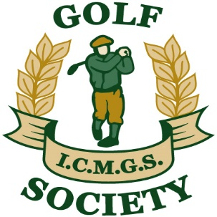

RESULTS

Event: Grey Silo ... July 22, 2017

Sponsor: Kevin Arey and the Golf Society
________________________________________________

1st Place: Al Leroux 46 Pts

2nd Place: Kevin Barry 41 Pts

3rd Place: Tommy Porter 40 Pts

4th Place: Jim Gilchrist 39 Pts (On countback)

Low Gross: Donal O’Shea 83 strokes

Ladies Winner: Claire Hughes 29 Pts

Best Front Nine: Kevin Loughnane 21 Pts

Best Back Nine: Sean Kelly 21 Pts (On countback)

Nearest The Pin -- Men: Brian Hutchinson

Money Hole Winner: Jim Gilchrist

