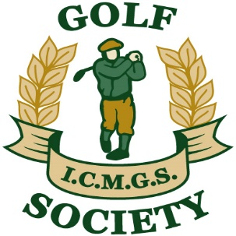

RESULTS

Event: Savannah – September 16, 2017

Sponsors: Eugene Devlin and the Golf Society

1st Place: Declan Neary 39 Pts (On countback)

2nd Place: Jim Gilchrist 39 Pts (On countback)

3rd Place: Brian Hutchinson 39 Pts

4th Place: Mike Byrne 36 Pts

Ladies Winner: Debbie Snyders 29 Pts

Low Gross Winner: Brendan Baragwanath 86 strokes

Best Front Nine: Gerry O’Donoghue 19 Pts

Best Back Nine: Alan Ryan 21 Pts

Nearest The Pin – Men: Gabriel Rushe

Money Hole Winner: Mike Byrne

