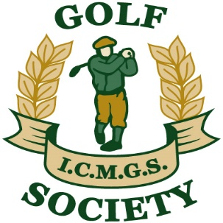

RESULTS

Event: Willow Valley ... May 20, 2017

Sponsor: Doug Cussons
________________________________________________

1st Place: Jim Douglas 68 Strokes

2nd Place: Jim Gilchrist 69 Strokes

3rd Place: Bill Jeffery 71 Strokes

4th Place: Donal O’Connor 72 Strokes

Low Gross: Lee Morley 89 Strokes

Ladies Winner: Debbie Snyders 71 Strokes

Best Front Nine: Jim Patton

Best Back Nine: Patrick O’Leary

Nearest The Pin -- Men: Dick Harrison

Nearest the Pin -- Ladies: Sheelagh Byrne

Money Hole Winner: John Langan

