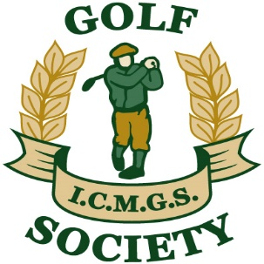

RESULTS

Event: Carlisle – October 7, 2017

Sponsor: John Rudden

Overall Winner: Brian Hutchinson

Flight “A” Winner: Kevin Barry

Flight “B” Winner: Sean Kelly

Flight “C” Winner: Patrick O’Leary

Ladies Winner: Sheelagh Byrne

Low Gross Winner: Martin Dullea

Best Front Nine: Kevin Loughnane

Best Back Nine: Mike Byrne

Nearest The Pin – Ladies: Sheelagh Byrne

Money Hole Winner: Sean Kelly

