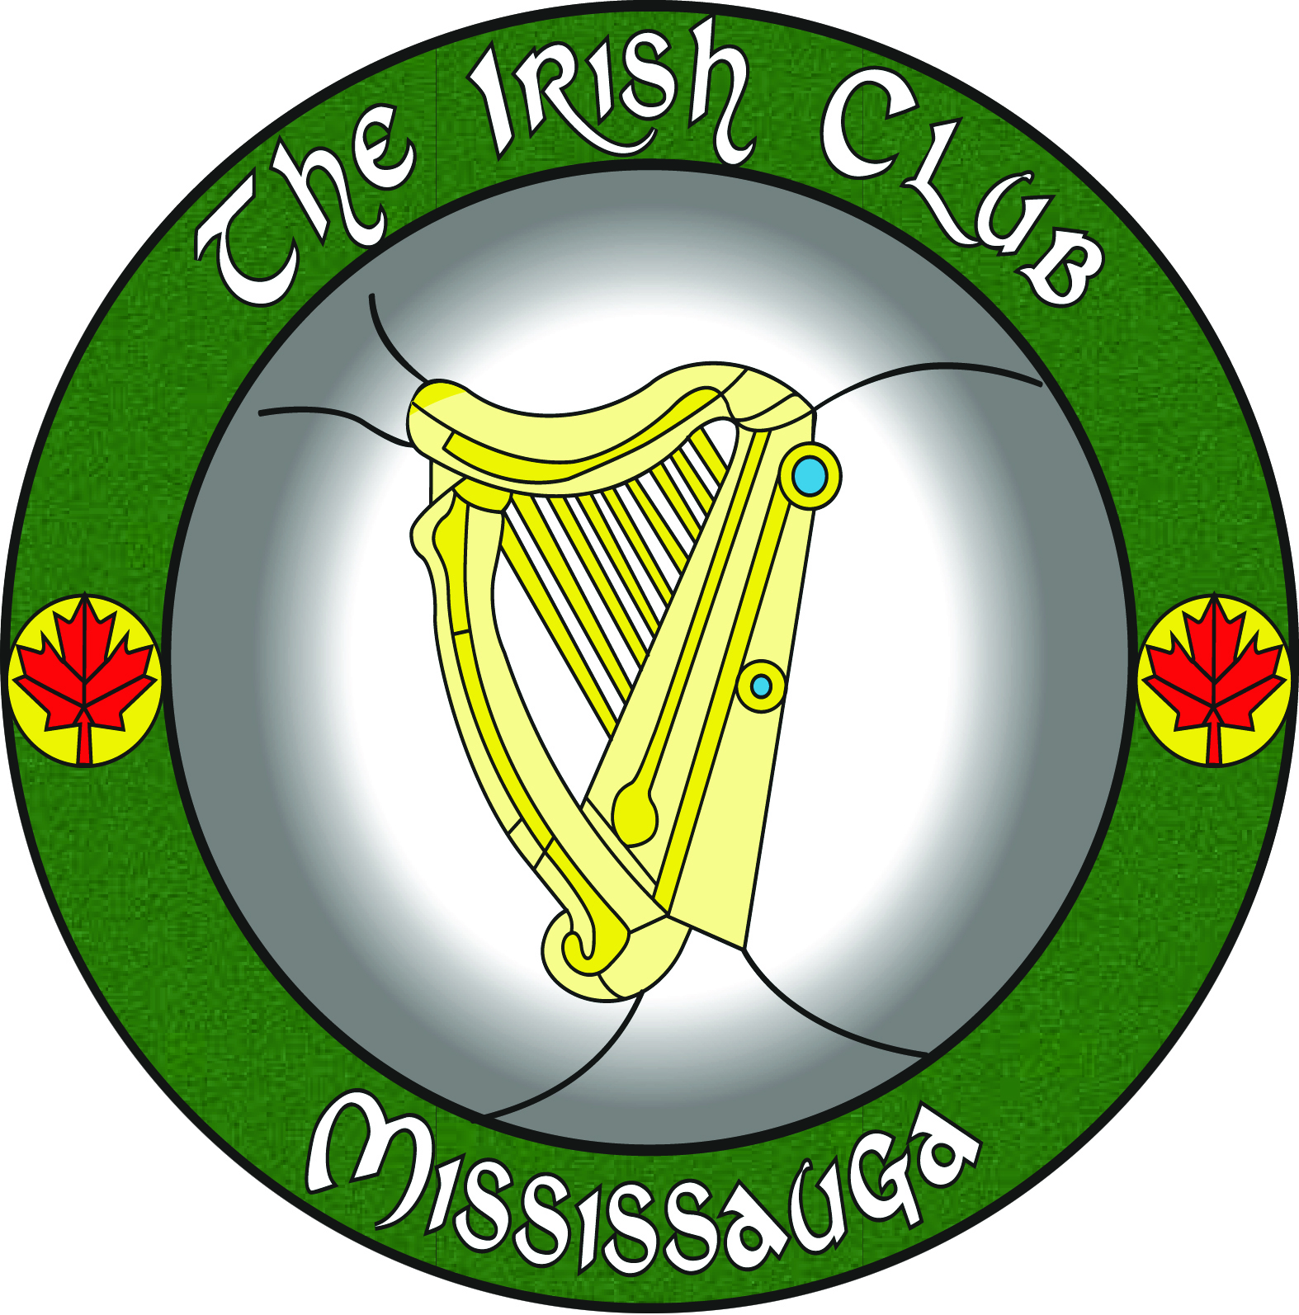
Taca na hEireann
IRISH CLUB OF MISSISSAUGA
CLUB RULES & CODE OF CONDUCT

- TO ACT IN A RESPECTFUL MANNER TOWARDS FELLOW MEMBERS, GUESTS AND ESPECIALLY TOWARDS CLUB VOLUNTEERS. VERBAL ABUSE WILL NOT BE TOLERATED.

- TO ACT IN A MANNER WHICH PROMOTES HARMONY AND FELLOWSHIP AND REJECTS THAT WHICH PROMOTES RACIAL, SECTARIAN, POLITICAL, AND GENDER DISHARMONY AND OTHER TYPES OF DIVISIVE BEHAVIOUR.

- TO SUPPORT AND COMPLY WITH DECISIONS OF BAR STAFF AND COMMITTEE MEMBERS, KEEPING THE BEST INTERESTS OF THE CLUB IN MIND AT ALL TIMES. ACCEPT AND SUPPORT SUCH DISCIPLINARY ACTION AS THE COMMITTEE DEEMS NECESSARY WHEN DEALING WITH CONFLICTS.

- TO RESPECT AND SAFEGUARD CLUB PROPERTY AND THE PERSONAL PROPERTY OF MEMBERS AND GUESTS.

- THEFT AND/OR WILLFUL DAMAGE ARE UNACCEPTABLE AND SUBJECT TO DISCIPLINARY AND/OR LEGAL ACTION.

- LOUD AND BOISTEROUS BEHAVIOUR, SWEARING, THREATENING, SHOUTING, USING INSULTING LANGUAGE, INCITING HATRED, FIGHTING, IMPEDING OR MOLESTING OTHERS WILL RESULT IN THE OFFENDER BEING REQUIRED TO APPEAR BEFORE THE COMMITTEE. THE COMMITTEE WILL TAKE APPROPRIATE DISCIPLINARY ACTION, UP TO AND INCLUDING THE REVOKING OF MEMBERSHIP.

- MEMBERSHIP MUST BE PAID IN FULL AND BE RENEWED BY THE END OF JANUARY OF THE UPCOMING YEAR. GUESTS TO THE CLUB MUST BE SIGNED IN BY A MEMBER, WHO WILL BE RESPONSIBLE FOR THE DURATION OF THE GUEST’S VISIT. GUESTS WILL BE ALLOWED THREE VISITS BEFORE BEING REQUIRED TO BECOME MEMBERS. THE THREE-VISIT RULE SHALL APPLY TO ALL GUESTS.

- COMPLAINTS MUST BE IN WRITING, SIGNED AND ADDRESSED TO THE SECRETARY. THE COMMITTEE WILL REVIEW ALL COMPLAINTS.

- PROMOTE THE CONTINUED SUPPORT OF OUR CLUB WITHIN THE GREATER COMMUNITY.

- NO MEMBER OR GUEST SHALL BRING PERSONAL ALCOHOLIC BEVERAGES INTO THE CLUB AT ANY TIME. MEMBERS OR GUEST WHO ARE IN VIOLATION OF THIS CODE SHALL LOSE THEIR PRIVILEGES TO ATTEND THE CLUB.

**By authority of the Committee of the Irish Club of Mississauga

