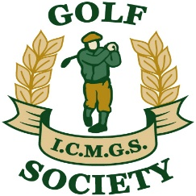

Captain's (Doug Cussons) Day

Piper's Heath - August 19th, 2016

Sponsors: Past Captains of the Society

Overall Winner: Brendan Baragwanath 40 Pts

Flight “A” Winner: Mike Byrne 36 Pts (On countback)

Flight “B” Winner: Jim Gilchrist 33 Pts

Flight “C” Winner: Jim Maguire 35 Pts

Low Gross Winner: Martin Dullea 87 Strokes

Best Front Nine: Shay Daly

Best Back Nine: Gabriel Rushe (On countback)

Nearest The Pin - 6th: Sean Kelly

Nearest The Pin - 11th: Martin Dullea

Nearest The Pin - 13th: Jim Maguire

Money Hole Winner: Gerry O’Donoghue

