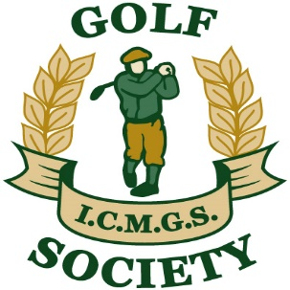

RESULTS – Captain’s (Garry O’Sullivan) Day

Event: Granite Ridge ... August 13th, 2022

Sponsors: Past Captains

Kevin Arey, Brendan Baragwanath, Kevin Barry, Peter Byrne, Sheelagh Byrne, Doug Cussons, Jimmy Fay, Declan Kidd, Sue Masterman, Tommy Porter
________________________________________________

Overall Winner: Maurice Cussen 46 Points

Flight “A” Winner: Keith Duffy 44 Points

Flight “B” Winner: Tom Merrick 39 Points

Flight “C” Winner: Padraig Boyd 39 Points

Ladies Flight: Bernadette O’Sullivan 43 Points

Low Gross: Lee Morley 85 Strokes

Best Front Nine: Joe Wilson 22 Points

Best Back Nine: Jim Long 20 Points

Nearest The Pin – 3rd: Sue McArthur

Nearest The Pin – 5th: Gerry O’Donoghue

Money Hole – 16th: Declan Neary

