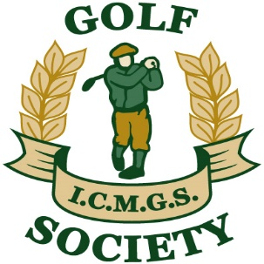

RESULTS

Event: Willow Valley ... October 3, 2020

Sponsors: Peter and Sheelagh Byrne and Declan Kidd
________________________________________________

Overall Winner: Doug Cussons 45 Points

Flight “A” Winner: Mick Toner 43 Points

Flight “B” Winner: Tom Mulvany 37 Points

Flight “C” Winner: Jimmy Fay 37 Points

Low Gross: Martin Dullea 79 Strokes

Best Front Nine: Jim Gilchrist 22 Points

Best Back Nine: George Caddoo 22 Points

Nearest The Pin – 5th: Chris Harkness (G)

Nearest The Pin – 13th: Tied: Pat Murray and Tom Mulvany

Nearest The Pin – 15th: Lucas Brinkhof (G)

Nearest The Pin – 17th: Randy Gehlen (G)

Money Hole – 8th: Kevin Barry

