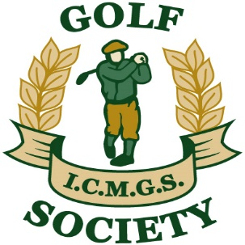

RESULTS

Event: Victoria Park - April 23, 2016

Sponsors: The Rugby Boys

Overall Winner: Doug Cussons 41 Pts

Flight “A” Winner: Donal O’Shea 40 Pts (On countback)

Flight “B” Winner: Jim Patton 36 Pts (On countback)

Flight “C” Winner: Steve Brigden 30 Pts

Ladies Winner: Claire Hughes 32 Pts

Low Gross Winner: Brendan Baragwanath 81 Strokes

Best Front Nine: Gerry O’Donoghue 19 Pts (On countback)

Best Back Nine: Greg Freeman 22 Pts

Nearest The Pin – Men: Jim Douglas

Money Hole Winner: Cory Gibner

