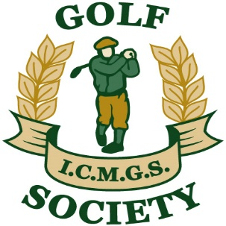

RESULTS

Event: Victoria Park - April 20, 2017

Sponsors: The Rugby Boys

Overall Winner: Shay Daly 40 Pts

Flight “A” Winner: Dave Harrison 36 pts

Flight “B” Winner: Jim Patton 37 Pts

Flight “C” Winner: Donal O’Connor 35 Pts

Ladies Winner: Sheelagh Byrne 28 Pts

Low Gross Winner: Mike Shanahan 87 (On Countback)

Best Front Nine: Martin Dullea 20 Pts

Best Back Nine: Kevin Arey 21 Pts

Nearest The Pin – Men: Mike Byrne

Money Hole Winner: Brendan Baragwanath

