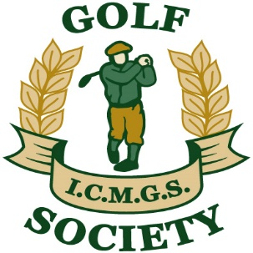

RESULTS
Event: Victoria Park ... May 29, 2021
Sponsor: John Rudden – TriGreen Construction
1st Place: Kevin Arey 40 Pts
2nd Place: Gerry O’Donoghue 39 Pts
3rd Place: Doug Cussons 37 Pts (On Count-back)
4th Place: Brendan Baragwanath 37 Pts (On Count-back)

Low Gross: Richard Ellis Smith 84 strokes ( On Count-back )
Best Front Nine: Martin Holroyde 19 Pts
Best Back Nine: Bob Saylor 24 Pts
Nearest The Pin – 4th: Gabriel Rushe
Nearest The Pin – 6th: Jim Gilchrist
Nearest The Pin – 11th: Gerry O’Donoghue
Nearest The Pin – 15th: Brendan Baragwanath
Money Hole Winner: Lee Morley

